Assignment 2
Operating Systems
Handwritten assignment on A4 pages is to be submitted on portal in PDF.
Q1. Consider following four processes: P1 to P4. Draw Gantt chart and find average wait time, turn-around time and average response time of the processes using the following scheduling policies.
- FCFS
- SJF (Preemptive)
- Priority (higher the number greater the priority)
Calculate the average waiting time, average turnaround time using Gantt chart.
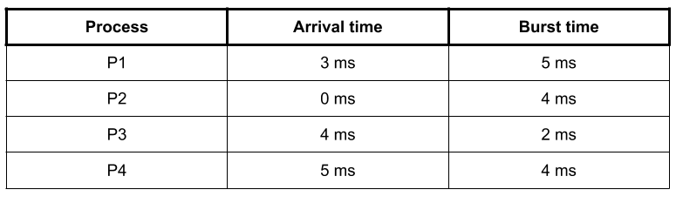 | Priority
 | P0
 | P1
 | P2
 | P3

